

[Artificia](https://doi.org/10.1016/j.ailsci.2023.100073)l[IntelligenceintheLifeSciences3(2023)100073](https://doi.org/10.1016/j.ailsci.2023.100073)

|  |  |  |
| --- | --- | --- |
|  | Contentslistsavailableat[ScienceDirect](http://www.ScienceDirect.com) |  |
| ArtificialIntelligenceintheLifeSciences |
| journalhomepage:[www.elsevier.com/locate/ailsci](http://www.elsevier.com/locate/ailsci) |

ResearchArticle   
Designingmicroplatelayoutsusingartificialintelligence MaríaAndreínaFranciscoRodríguez∗,JordiCarrerasPuigvert,OlaSpjuth *DepartmentofPharmaceuticalBiosciencesandScienceforLifeLaboratory,UppsalaUniversity,Sweden*

|  |  |  |
| --- | --- | --- |
| article | info | abstract |
| *Keywords:*  Platedesign  Plateeffects  Qualitycontrol |  | Microplatesareindispensableinlarge-scalebiomedicalexperimentsbutthephysicallocationofsamplesand controlsonthemicroplatecansignificantlyaffecttheresultingdataandqualitymetricvalues.Weintroduce anewmethodbasedonconstraintprogrammingfordesigningmicroplatelayoutsthatreducesunwantedbias andlimitstheimpactofbatcheffectsaftererrorcorrectionandnormalisation.Wedemonstratethatourmethod appliedtodose-responseexperimentsleadstomoreaccurateregressioncurvesandlowererrorswhenestimating IC50/EC50,andfordrugscreeningleadstoincreasedprecision,whencomparedtorandomlayouts.Italsoreduces theriskofinflatedscoresfromcommonmicroplatequalityassessmentmetricssuchas*𝑍*′factorandSSMD.We makeourmethodavailableviaasuiteoftools(PLAID)includingareferenceconstraintmodel,awebapplication, andPythonnotebookstoevaluateandcomparedesignswhenplanningmicroplateexperiments. |

**1.Introduction**

Intheeraofdata-drivenlifescience,theamountsofdataproduced arecontinuouslyexpanding,andartificialintelligencetechniquessuch asmachinelearningalgorithmsareseeingadoptionformanyapplica-tionsinordertoconvertthedataintoactionableinsights[1–5].While inmanyapplicationstheprimaryfocushasbeentoobtainasmuchdata aspossible,theimportanceofhavingdataofhighqualitycannotbe understated[6–8].Forlarge-scalebiomedicalexperiments,manyissues relatedtodataqualitypertainingtohumanoperationscanbeeffectively reducedoreliminatedbyusingautomatedsetupsandrobotisedequip-ment[9].However,severalartefactsduetophysical,biological,and temporalconditionsstillremain,andeffortsgeneratinglargequantities ofdatacanbefruitlessifintheendconclusionscannotbedrawndueto data-qualityissues.Acommonapproachtoincreasetheconfidencein thedataistoperformmultipletechnicalandbiologicalreplicates,but thisisassociatedwithhighercostsandlongerexperiments,andoften leadstoatrade-off betweenthenumberofsamplesanalysedandthe numberofreplicatespersample.Anotherapproachisto*improvetheex-perimentaldesign*,withtheaimtocarryouttheexperimentinsuchaway thatitmaximisestheconclusionsthatcanbedrawnfromtheresulting data[10].

Microplates,ormicrowellplates,arestandardcomponentsinmany biomedicalexperiments.Theyareflatplateswithmultiplewellsused assmalltesttubes,organisedina2:3matrix.Theycomeinastandard physicaldimensiontoensurecompatibilitywithdifferentlabequip-ment,andtypicallycontain24,96,384,or1536wells.Experiments

carriedoutusingmicroplatescommonlyexhibitplateeffects[11],also knownaspositionaleffects,whicharesystematicvariationsacrossthe geometryofamicroplate(within-plateeffects)oracrossdifferentplates (between-plateeffects)duetofactorssuchaswelllocation,tempera-tureandhumiditybeingunequallydistributed,andcanaffectthere-sultstothepointofrenderingtheexperimentunusable.Otherfactors thatcancontributetoexperimentalvariationarethelabequipment, suchasimprecisemanualpipetting,andinconsistentormalfunctioning liquidhandlinginstruments.Commonpatternsofwithin-plateeffects include:(i)linearroweffects;(ii)linearcolumneffects;(iii)linearrow andcolumneffects;and(iv)bowl-shapedspatialeffects[11];examples arevisualisedinFig.1.Identifyingandcorrectingforbothwithin-and between-plateeffectsisimportantinordertoadjustthedatasothatthe impactoftheerrorscanbereducedoravoided.Variousnormalisation techniqueshavebeendevelopedtothisend[12,13],butanappropriate microplatelayoutisofparticularimportanceforthenormalisationto beeffective[12,14].A*control*isasamplethathasbeensubjectedtoa knowntreatmentwiththegoalofaccountingfortheeffectsofvariables otherthanwhatisbeingtested,thusincreasingthereliabilityofthere-sults.Inparticular,a*negativecontrol*isasamplethathasbeensubjected toatreatmentthatinducesnoeffect,whilea*positivecontrol*isasam-plethathasbeensubjectedtoatreatmentwithanexpectedmaximal response[15].Inordertomitigateplateeffectsandgainthemostout ofusingcontrolsamplesanderrorcorrectionmethods,scientistshave beenadvocatingfortheuseofrandomisedplatelayouts[16,17]. Awidelyusedapproachtodayistodesignplatelayoutsmanually inordertosimplifyforhumaninteraction;e.g.placingcontrolsinthe

∗Correspondingauth[or.](mailto:maria.andreina.francisco@farmbio.uu.se)

*[E-mailaddresses:](mailto:ola.spjuth@farmbio.uu.se)*[maria.andreina.francisco@farmbio.uu.se](mailto:maria.andreina.francisco@farmbio.uu.se)(M.A.FranciscoRodríguez),[jordi.carreras.puigvert@farmbio.uu.se](mailto:jordi.carreras.puigvert@farmbio.uu.se)(J.CarrerasPuigvert), [ola.spjuth@farmbio.uu](mailto:ola.spjuth@farmbio.uu.se)[.se(O.Spjuth).](mailto:maria.andreina.francisco@farmbio.uu.se)

<https://doi.org/10.1016/j.ailsci.2023.100073>  
[Received18January2023;Receivedinrevise](https://doi.org/10.1016/j.ailsci.2023.100073)dform8March2023;Accepted12April2023   
Availableonline14April2023   
2667-3185/© 2023TheAuthors.PublishedbyElsevierB.V.ThisisanopenaccessarticleundertheCCBYlicense(<http://creativecommons.org/licenses/by/4.0/>)

*M.A.FranciscoRodríguez,J.CarrerasPuigvertandO.Spjuth*  *ArtificialIntelligenceintheLifeSciences3(2023)100073*

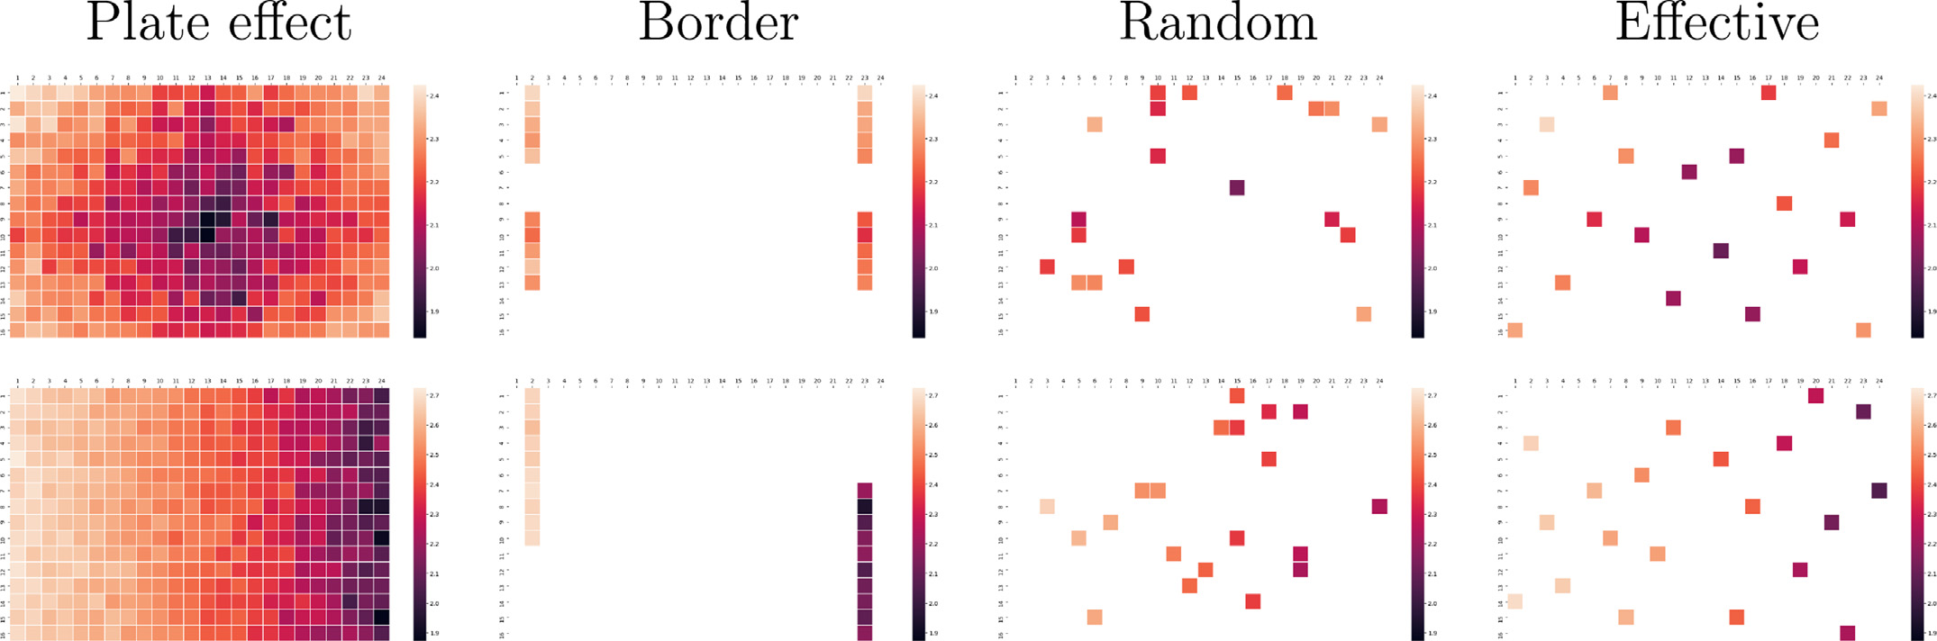

**Fig.1.**Visualisationofsystematicplateeffectsanddistributionsof20negativecontrolsusingborder,randomandeffectivelayouts.Thecoloursindicatetheintensity

measuredateachwell.Toprow:Datawithstrongsystematicerrorshavingabowl-shapedrelationshiptowellposition.Bottomrow:Datawithstrongsystematic

errorshavingalinearrelationshiptocolumnnumber.

outer-mostwells(borderlayout)anddistributingthesamplesfollowing patternsthatareeasytodesignandtopipettemanually[18,19].Indeed manyresearchersstilluseborderlayoutsastheyhelpreducehuman pipettingerrors,allowforstraight-forwardvisualisationofresultsby humans,forexampleintheformofheatmaps[12],andcanbeeasily designedusingpenandpaper[20].Yetborderlayoutscanonlybeused toeffectivelyidentifyandadjustforonlyafewplateeffects[13,14], suchaslinearrelationshipstorowsorcolumnsthataffectthewhole plate(Fig.1).

Forlarge-scaleexperimentswithmicroplateshaving384ormore wells,humanpipettingbecomesinfeasibleandrobotsforliquidhan-dlingarenecessary.Inrecentyears,pipettingrobotshavebecomecom-moninbiomedicallabsandtheyallowforfullyflexiblearrangementsof controlsandsamplesonplates,makingrandomisedlayoutsmoreacces-sible.However,purerandomisationcanstillproduceineffectivelayouts, forexamplelargeareasoftheplatemightendupnothavinganycon-trolsamples,makingitdifficultorevenimpossibletodetectandcorrect errorsinthoseareas[16,21,22].Further,replicatesplacedinadjacent wellsarethenlikelytobeaffectedbythesameplateeffects.Notonly isitaproblemthattheywillbesimilarlybiased,butithasalsobeen shownthatclustersofsimilarsamples,includingsimilardosesofthe samecompoundaswellastechnicalreplicates,canaffecttheresults ofadjacentwells[12].Consequently,platedesignsthatdistributeboth controlsandsamplesinaneffectivewayareneededinordertoreduce unwantedbias,aswellastoaidtodetectandcorrectplateeffects.We refertosuchdesignsas*effective*layouts.Figure1(toprow)displays examplesofmicroplateswithtwostrongsystematicplateeffects(bowl-shapedandlineargradient)andexamplesofhowcontrolscanbelocated usingborder,randomandeffectivelayouts.

Severalplatelayouteditorsareavailable,suchasBrunn[23], FlowJo[24],Labfolder[25],PlateDesigner[26],andPlateEditor[27]. Whilesomeareabletogeneraterandomisedlayouts,noneofthemhave capabilitiestogenerateeffectivelayouts.Thereis,ofcourse,thepossi-bilityofgeneratingseveralrandomlayoutsandthenevaluatethemin ordertoselectthebestone[28],butthatdoesnotguaranteethateffec-tiveplatelayoutshavebeenselected,regardlessofhowmanylayouts aregenerated.

Inthismanuscriptweintroduceanartificial-intelligencebased modelfordesigningeffectivemicroplatelayoutsthatcaneasilybe adaptedfordifferentexperimentalsettings,andevaluateitfordose-responseandscreeningapplications.Inordertosimplifyitsusage,we developedasuiteoftools(PLAID),includingaweb-appforeasilyde-signingeffectivemicroplatelayouts,togetherwithPythonnotebooksfor simulatingdifferentexperimentaldesignsandallowforplanningand designingeffectiveexperiments.

2

*M.A.FranciscoRodríguez,J.CarrerasPuigvertandO.Spjuth*

detected,especiallywhentheerrorshavebeenintroducedconsistently inallplates,forexamplebyamalfunctioningdispensingequipment. Thesameconstraintscouldalsobeappliedtosamplereplicatesacross plates.

*1.2.Effectivelayoutswithconstraintprogramming*

Aboveweintroduceddesiredpropertiesofeffectiveplatelayoutsas asetofconstraints.Oneoptiontosatisfytheseconstraintswouldbe torandomlygeneratemicroplatelayoutsuntilonethatfitsthecriteria isfound.Whilethisinitselfconstitutesanon-trivialtask,findingsuch layoutcouldtakeanunreasonablylongtime,andifnolayoutfulfilling thecriteriaexists,thisprogramwouldneverfinish.Amoreefficientand naturalsolutionistoframeourcharacterisationofeffectivemicroplate layoutsasaconstraintsatisfactionproblem(CSP):wevieweachwell ofeachplateasavariablewhosevaluerepresentsitscontentanddesir-ablepropertiesofalayoutasconstraints.*Constraintprogramming*(CP) isasubareaofartificialintelligencethatoffersaflexibleframework forsolvingconstraintsatisfactionproblemsthathasseenlargeadoption invariousfields(seeMethodssection).ThegeneralideabehindCPis thataCSPcanbemodelledasaconjunctionofhigh-levelconstraints onvariablesrangingoverinitialdomains,andthensaidmodelisgiven toageneral-purposeconstraintsolverwhichperformsacombinationof intelligentreasoningandsystematicsearchinordertofindconstraint-satisfyingdomainvaluesforthevariables.Inthisprojectweimplement aconstraintmodelthatgenerateseffectiveplatelayoutsfortwodiffer-entapplications:dose-responseandscreeningexperiments.

**2.Effectivelayoutsleadtomoreaccurateresultsin dose-responseexperiments**

Dose-responseexperimentsattempttoevaluatetheeffectofasub-stanceinaspecificassayatincreasingconcentrations[29].Theeffect can,inmanycases,beestimatedbyfittingasigmoidcurvetothedata points,andisfrequentlysummarisedbydeterminingthehalfmaximal inhibitoryconcentration(IC50),orthehalfmaximaleffectiveconcen-tration(EC50).Inordertoevaluatetheimpactofdifferenttypesofmi-croplatelayoutsindose-responseexperiments,wesimulatedatotalof 43,200microplatesfordoseresponseexperimentswithborderlayouts, randomlayouts,andeffectivelayoutsgeneratedusingconstraintpro-grammingandtheconstraintsdefinedinSupplementaryListing1.The experimentsconsistedof20compoundsofvaryingpotencyin6,8,and 12doses,andfor1,2,and3replicates.Plateeffectsaddedhadarela-tionshiptocolumnnumberorwerebowl-shaped,bothinmediumand highstrength.Thedatawasnormalisedusinglinearregressioninthe caseofborderlayouts,andLOESSregressionforeffectiveandrandom layouts,andfour-parameterlog-logistic(LL4)curveswerefittedtothe resultingdata.ExamplesofthecurvesproducedcanbeseeninFig.2(a) andSupplementaryFig.1.Foracompletedescriptionoftheexperiment, seeMethodssection.

Figure2(b)andSupplementaryFig.12showthemeansquareder-ror(MSE)oftheresidualscalculatedwithrespecttothedose-response curvesusedtogeneratethedata.Itisevidentthat,aftererrorcorrection usingLOESSregressionandnormalisingtothemeanofthenegativecon-trols,effectivelayoutsleadtostatisticallysignificantsmallerMSEthan othertypeslayouts(*𝑝<*10−4forallpairwisecomparisons,*t*-test).That is,thedataobtainedusingoureffectivelayoutsismuchclosertotheir expectedvalues,thanthedataobtainedwhenusingeitherrandomand borderlayouts.

Itisstandardpracticetodiscarddose-responsecurvesthatarecon-sideredtohavelowquality,forexample,curveswheremorethan20%of thevariabilityisunexplainedbythecurvefit,thatis,with*𝑅*2*<*0*.*8[15]. Ingeneral,oureffectivelayoutsleadtoahigherpercentageofhigh-qualitycurves,ascanbeseeninSupplementaryFigs.13–15.Forex-ample,inthecaseofexperimentswith8dosesand3replicates,and strongplateeffectswithalinearrelationshiptocolumnnumberonthe

3

*M.A.FranciscoRodríguez,J.CarrerasPuigvertandO.Spjuth*  *ArtificialIntelligenceintheLifeSciences3(2023)100073*

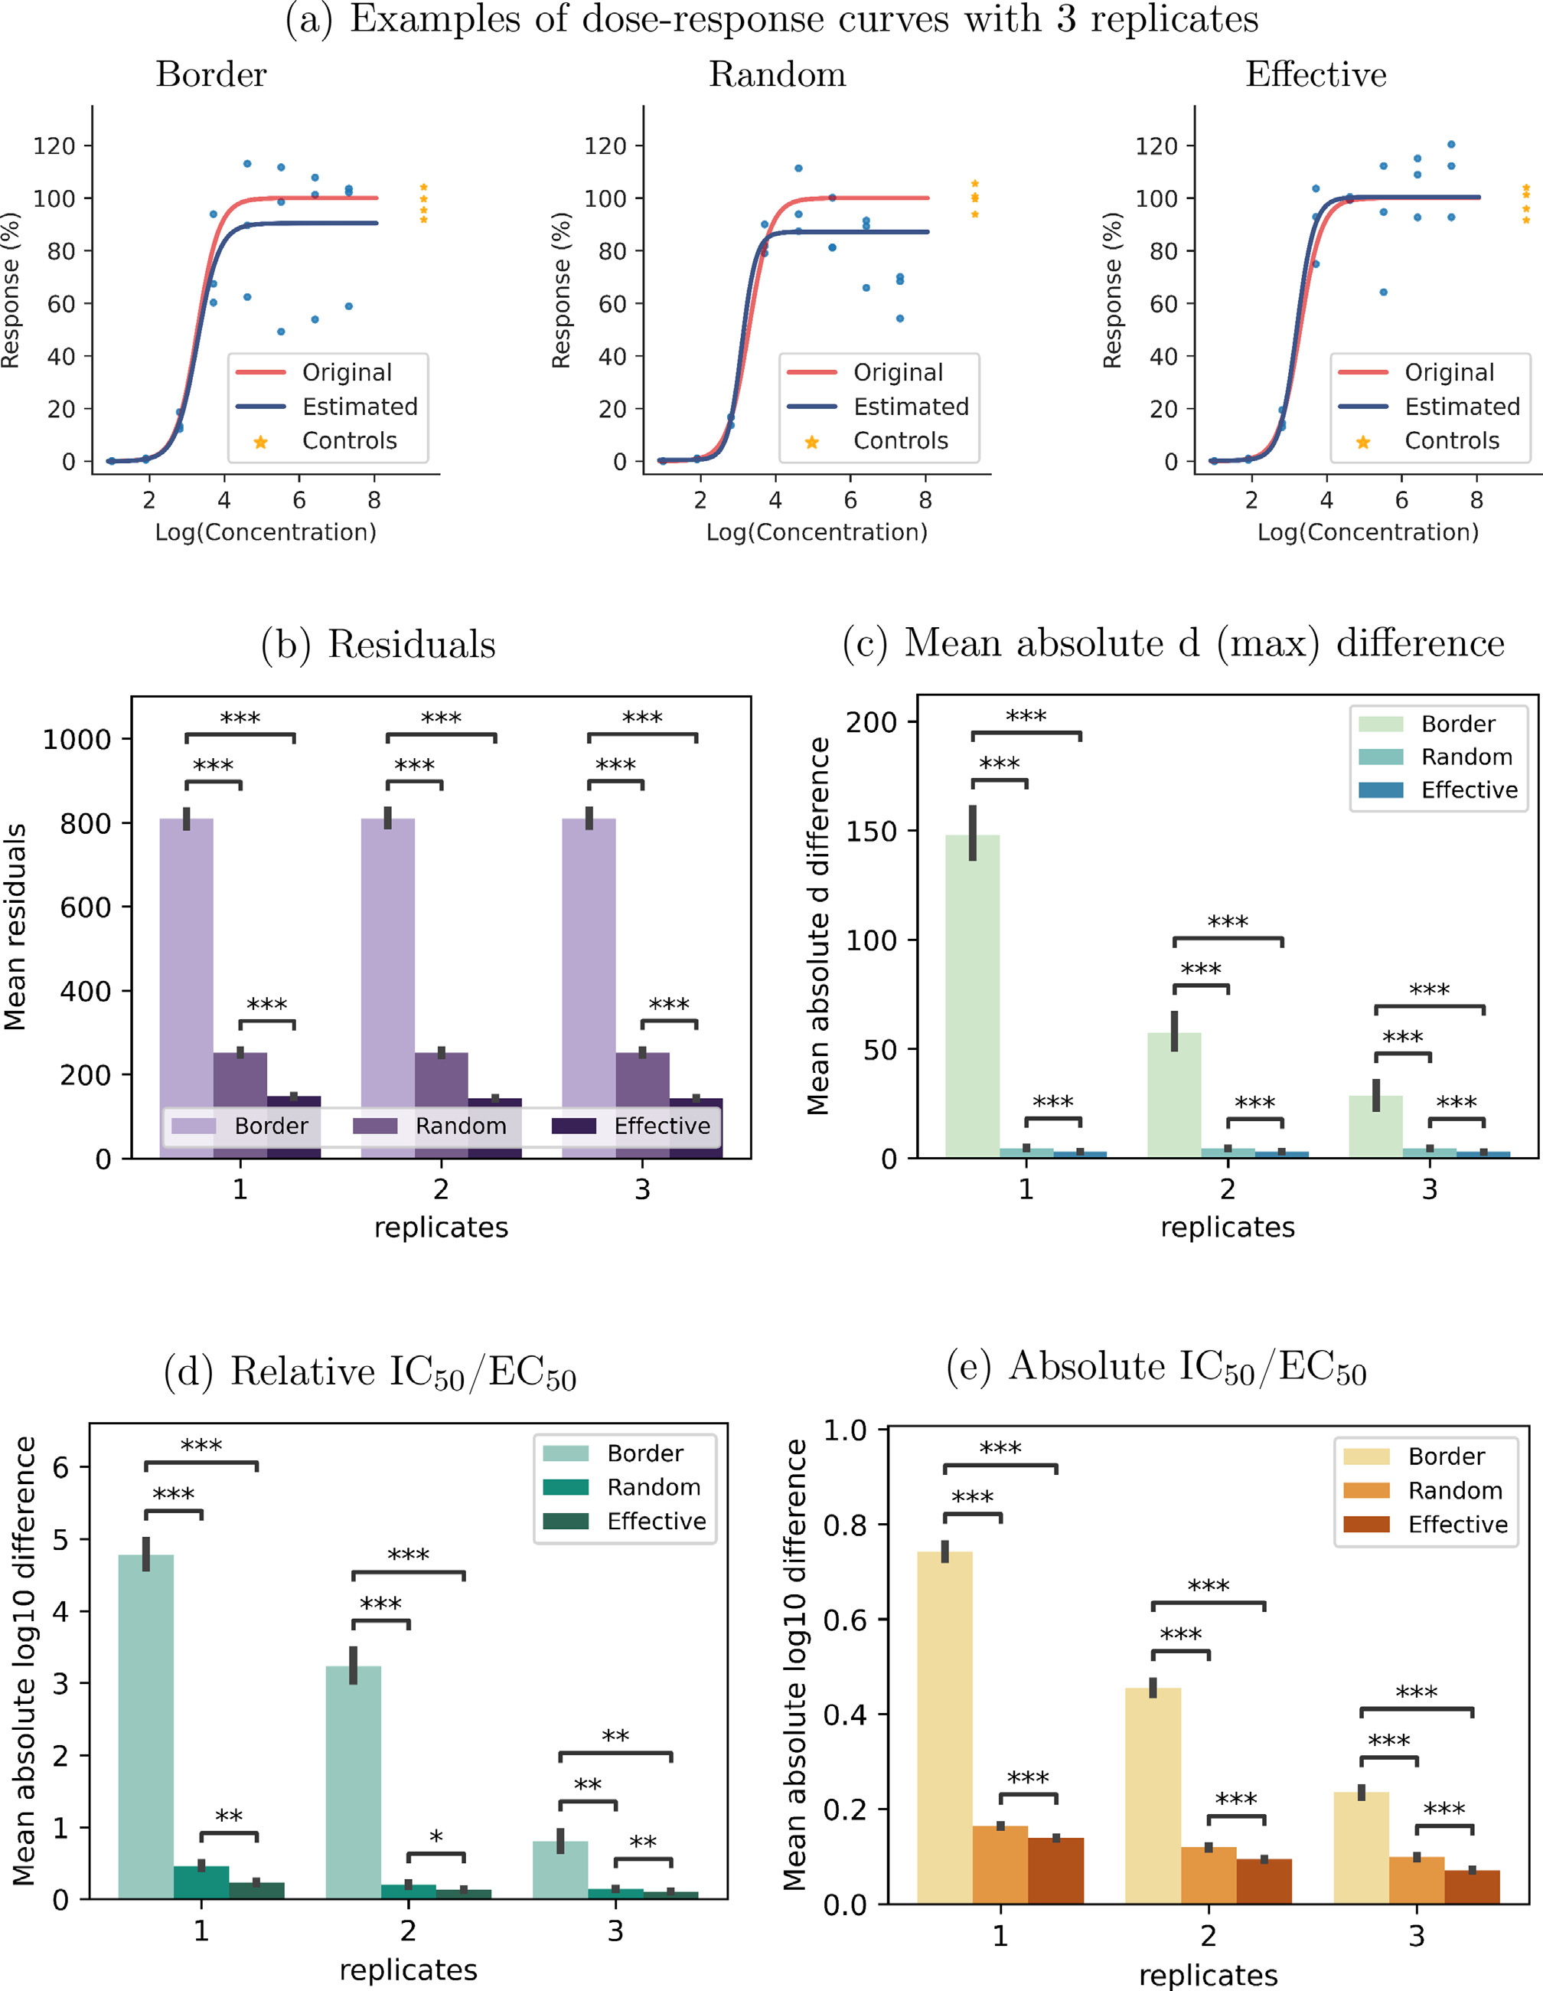

**Fig.2.**Comparisonbetweenexpectedandobtainedvaluesfordoseresponsecurveswith8doses,1,2,or3replicates,20negativecontrolson384-wellplate,and

strongplateeffectswithalinearrelationshiptocolumnnumberontherightsideoftheplate.∗indicates*𝑝<*10−4,∗∗indicates*𝑝<*10−12,∗∗∗indicates*𝑝<*10−43.

4

*M.A.FranciscoRodríguez,J.CarrerasPuigvertandO.Spjuth*  *ArtificialIntelligenceintheLifeSciences3(2023)100073*

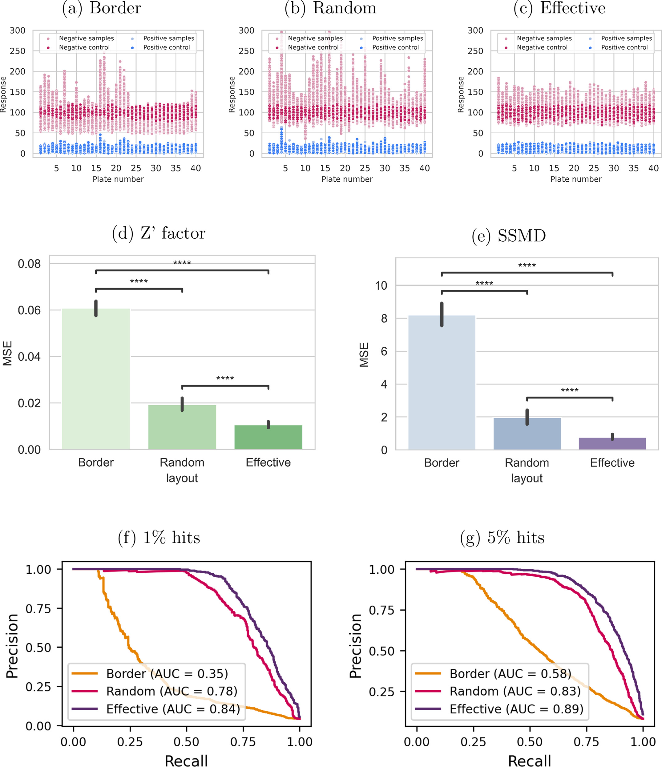

**Fig.3.**Screeningexperimentsconsistingof40microplatesforeachtypeoflayout,eachwith10positiveand10negativecontrolsandonly1replicatepercompound. Hitsarerandomlydistributedoneachplate.(a)–(c):Simulatedresponsedatawith1%hitrateaftererrorcorrectionandnormalisationinthepresenceofmildbowl-shapedplateeffects.MSEbetweenexpectedandobtained(d)*𝑍*′factorand(e)SSMDinthepresenceofmildbowl-shapedplateeffects.Theexpectedvalueswere calculatedusingplatesrandomlyfilledwith50%positivecontrolsand50%negativecontrols,constitutingtheoptimalvaluesobtainablebythesemetrics.(f)and (g):PR(precisionrecall)curvesforexperimentswithvaryinghitratesinthepresenceofstrongbowl-shapedplateeffects.

5

*M.A.FranciscoRodríguez,J.CarrerasPuigvertandO.Spjuth*

dicatedbylowmetricscores,butwherehighscoresarenotaguarantee forhigh-qualityresultsontheplate.Themainreasonforthisisthat both*𝑍*′factorandSSMDonlytakeintoaccountpositiveandnegatives controlsregardlessoftheirphysicallocationontheplate,andwitha sub-optimallayoutthesemetricsmightnotaccuratelycapturethereal plateeffects.Inordertoanalysetheeffectofdifferentlayoutsonqual-itymetrics,wecalculatedtheexpectedvaluesforboth*𝑍*′factorand SSMDusingwholeplatesfilledwith50%positivecontrolsand50% negativecontrols,constitutingtheoptimalqualityvaluesobtainableby thesemetrics.Wethencomparedtheresultingvaluesagainstthesame metricsbeingcalculatedusingonlyasubsetofthecontrolsontheplate accordingtoborder,random,andeffectivelayouts.Figure3(d)and(e) showthatforboththe*𝑍*′factorandSSMD,theestimatesobtainedus-ingeffectivelayoutsyieldaqualitymetricvaluethatisclosertothe expectedvaluewhencomparedtorandomandborderlayouts.Thisdif-ferenceisalwaysstatisticallysignificantaslongasthereissomedegree ofaplateeffect(SupplementaryFigs.23and24).

**4.ThePLAIDsoftwaresuite**

Inordertomakeourmethodeasilyaccessible,wedevelopedPLAID (PlateLayoutsusingArtificialIntelligenceDesign),asuiteoftoolsthat canbeusedtodesignandevaluatemicroplatelayoutsunderawide rangeofconditions.

*4.1.ThePLAIDreferenceconstraintmodel*

Weimplementedaconstraintmodelcomprisingtheconstraintsde-scribedhereusingMiniZinc[32].Advanceduserscaninteractwithand personalisethemodelbyaddingorremovingconstraints,whichcanbe ranusingtheMiniZincIDE,scripts,orcommandline.Itisalsopossi-bletoincorporatethemodelintoexistingworkflows,forexample,with thehelpoftheMiniZincPythonpackage.Instructionsonhowtorun ourMiniZincmodelusingthecommandlineortheMiniZincIDEare availableat<https://github.com/pharmbio/plaid>.

*4.2.ThePLAIDplatedesigntool*

InordertoeasetheuseofthePLAIDc[onstraintmodel,wedevel](https://plaid.pharmb.io/)oped aninteractivewebinterfaceavailableat<https://plaid.pharmb.io/>that allowsforspecifyingexperimentaldetail[sandgeneratinglayouts(](https://plaid.pharmb.io/)Sup-plementaryFig.25).Theexperimentaldesign(e.g.selectionofsam-ples,concentrations,etc.)canbedownloadedfromthewebinterface inaJSONformatthatcanbelateruploadedintothewebsiteinor-dertocreatemoreplatedesignsforthesameexperimentorasabase fornewexperiments.TheproducedlayoutsgeneratedbythePLAID constraintmodelcanbevisualisedwithinthewebinterface(Supple-mentaryFigs.26and27),anddownloadedinCSV,andJSONfile formats,aswellasanimage(SupplementaryFig.28).Producedlay-outsinJSONformatcanbere-uploadedintothewebsitetousethe visualisationfeatures(SupplementaryFigs.26and27).Examplesof bothexperimentalsettingsandlayouts,aswellasconveniencemeth-odsfortranslatinglayoutsintospecificformatstobedirectlyusedin EC[HOandI.DOTcompounddispensingrobot](https://www.github.com/pharmbio/plaid)s,areavailableonGitHub at<https://www.github.com/pharmbio/plaid>.

*4.3.ThePLAIDanalysisandvisualisationnotebooks*

Experimentdesignscansubstantiallyvary,andnoone-solution-fits-allexists.Differentassays,laboratoryconditions,equipment,etc,lead todifferenttypesandstrengthsofplateeffectsthataffectexperiments. WedevelopedinPythonalibraryofparametricplateeffects,alibrary ofplatenormalisationanderrorcorrectionfunctions,doseresponseand highthroughputscreeningsimulations,aswellasvisualisationfunction-ality.Thislibrarycanbeused,forexamplefromwithinPythonnote-books,toevaluatedifferentexperimentaldesigns,suchastoexplore

6

*M.A.FranciscoRodríguez,J.CarrerasPuigvertandO.Spjuth*

Thebenefitsandlimitationsofeffectivemicroplatelayoutsare tightlycoupledtotheuseandimpactofmethodsfordatanormalisa-tion,thatinturnaredependentontheuseof,andsufficientnumber of,controlsamples.Further,amulti-plateexperimentalsooffersmore opportunitiesforfindingeffectivelayouts.Inourworkwefocusedon LOESSnormalisation[34],whichisawidelyusednormalisationtech-niquethatisrobusttowardsdifferenttypesofplateandexperimental effects.Theerrormodelusedinthisworkisbasedontheoneproposed byZhangetal.[11],buttheintensityandtypeofplateeffectsobserved mightdifferdependingonfactorssuchasthetypeofexperiment,lab-oratoryfacilities,andtemperature,amongothers.Akeyadvantageof usingaconstraintmodelfordesigninglayoutsisthatsuchparameters canbeeasilyadjusted,duetothedeclarativenatureofthemodel,and evaluatedusingtheprovidedPLAIDPythonnotebooks.Wehaveput togetherasuiteofconstraintsthatarewidelyuseful,butthefinalselec-tionofconstraintsisuptothescientistsplanningexperimentsanditis easytoe.g.removeconstraintssuchas‘nosamplesinouterwells’ifthey arenotdesirable.Fromapracticalperspective,suchaswhenpipetting manually,itcanbebeneficialtousethesamesampleonlyononeplate. Forautomatedliquidhandlinginstruments,thenumberofplates(and hencesourcesamples)accessiblecanhaveanimpact.Thesescenarios arenotcoveredinthisstudy,butthereisnohindertoalsoimplement suchconstraintsintoaplatelayoutmodel.

*5.1.Iterativeexperimentation*

AImethodssuchasunsupervisedandsupervisedlearningarenowa-dayswidelyusedtoanalysetheresultsfromlarge-scaleexperiments usingmicroplates.Therearealsoemergingapproachestosequentially planaseriesofexperimentstosystematicallyimprovetheaccuracyof AImodels[35,36].Data-centricAIisaconceptthatproposestoshift fromthecurrentpracticeofhavingasetoffixeddataandthenspend-ingmuchtimeandefforttofine-tuneamachinelearningmodel,toin-steadfocusonaniterativeapproachtooptimisethedatausedtotrain themodel[37].Thismethodologyfundamentallybuildsonthepropo-sitionthathigh-qualitydataisbetterthanjustmoredata,something thatforalongtimehasbeenarguedintraditionalexperimentaldesign guidelines[33].Selectingthenextbatchofexperimentsishowevernon-trivial,andautonomousdecision-makingiscurrentlyanactiveresearch fieldwithautonomousvehiclesasabigdriver.Activemachinelearn-ingisoneapproachtoselectnewexperimentswhich,combinedwith robotics,hasthepotentialtoautomatescientificdiscoveries[38–41]. Fig.4showshowthePLAIDsuitesupportsiterativeexperimentation. Thefirststepconstitutesaninitialdecisiononsamples,replicates,con-trols,etc.,anditsdefinitioninadeclarativefileformatformicroplate experiments(SupplementarySection1).Thisexperiment-definitionfile istheninputtothePLAIDplatedesigntoolthatappliestheconstraint modeltogenerateeffectiveplatelayouts.Theproducedlayoutscanthen beevaluatedtowardssimulatedexperimentsdefinedbydifferenterror parameters,whichovertimecanbetailoredtoparticularexperimen-talandlaboratorysetups.Basedontheoutcomeofthesimulations,the experimentdesignmightberevisedandnewplatelayoutscanbegen-erated.Whenadecisionismadetoacceptthelayouts,thesecanbe translatedtocustomformatsthatcanbereadbylabinstruments.We providetranslationsfortwocommonchemicaldispensinginstruments (ECHOandI.DOT),butitisstraightforwardtocreatemoreadaptors forotherinstruments.Acceptingplatelayoutscanbedonemanually byhumans,orautonomouslyusinganalgorithm.Ifthedataacquisition andanalysisfromthephysicalexperimentscanbeautomated,thenonly thedecisionmakingregardingthenextroundofexperimentsremains. Giventhatautonomousdecisionmakinghasbeenimplementedinorder toselectthenextexperiment,itcanbedefinedinthePLAIDfileformat formicroplateexperiments,closingtheloopforthenextexperimentit-eration.Wespeculatethatsuchautomatedanditerativescientificexper-imentswillbeincreasinglycommoninthefuture,andthatPLAID,given itsflexibilityduetothedeclarativenatureofconstraintmodelling,its

7

*M.A.FranciscoRodríguez,J.CarrerasPuigvertandO.Spjuth*  *ArtificialIntelligenceintheLifeSciences3(2023)100073*

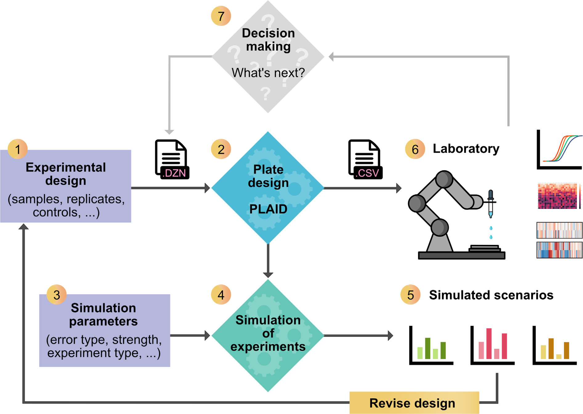

**Fig.4.**OverviewofthePLAIDecosystem.Experimentdesign(1)comprisestheselectionofsamples,replicates,concentrations,etc,andcanbedefinedinaconfig-urationfileorviathePLAIDPlateDesignwebinterface,andthenthePLAIDconstraintmodeliscalledtogeneratetheresultinglayouts(2).Inordertoevaluatethe design,simulationparameterssuchastypeandstrengthofexpectedplateeffectsneedtobedefined(3)andthenasimulatedexperimentusingthelayoutscanbe carriedoutinthePLAIDAnalysisandVisualisationNotebooks(4).Differentscenarioscanbecompared,suchasdifferentnumbersofconcentrationsandreplicates, anddesignsmaythenberevisedaccordingly.Whenanacceptabledesignhasbeengenerated,itcanbeusedtodriveliquidhandlinginstruments,suchasautomated pipetterobots(6).Aftertheexperimentisperformedandanalysed,adecisioncanbemadeonsubsequentexperimentse.g.confirmfindings,re-runfailedsamples, evaluatemoreconcentrations,etc.(7).ImplementingautomateddecisionmakingthatdefinesthenextexperimentinthePLAIDconfigurationfileformatenables autonomoussequentialexperimentation.

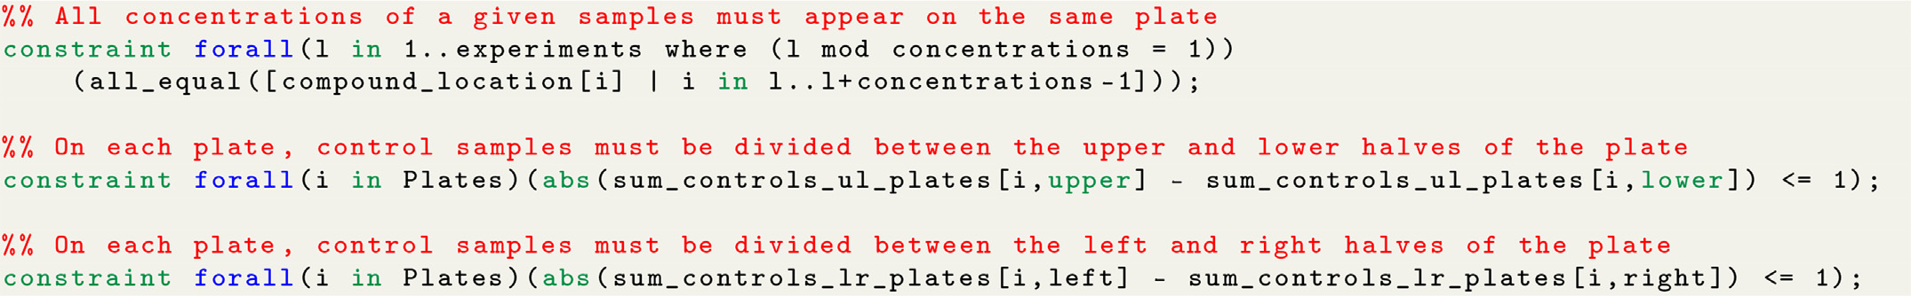

**Fig.5.**ExamplesofconstraintsinMiniZincsyntax.

Ontopofincludingallthedesirablepropertiesofeffectivemi-croplatelayouts,wehavechosentoincludeotherconstraintsthatare neededforpracticalmatters.Forexample,weenforcethatforeachsam-ple,allconcentrationlevelsofagivenreplicamustappearonthesame plate.Technicalreplicatesofasamplecanbechosentoappearonthe sameplate,onadifferentplate,oramixtureofboth.Wehavealso includedthedimensionsofthemicroplateasparametersintermsof numberofrowsandcolumns,allowingtheuseofanykindofplatesize. Finally,itisalsopossibletospecifyhowmanyrowsandcolumnsshould beleftemptyontheborderofeverymicroplateinordertomitigateedge effects.

8

*M.A.FranciscoRodríguez,J.CarrerasPuigvertandO.Spjuth*

ifasufficientnumberofconcentrationsweretobeused,acomplete doseresponsecurvewouldbegenerated.Togeneratethesigmoidcurves correspondingtoeachcompoundtheonlyparameterremainingtobe specifiedistheEC50/IC50.WegeneratedcurveswithEC50/IC50values rangingfrom1to96tosimulatecompoundshavingallkindsofpotency. Thehighestconcentrationwasarbitrarilysetto100μM.Foreachtest concentration,thereplicatesweregeneratedbyaddingarandomvalue within±1%tothevaluesampledfromthecurveinordertorepresenta verysmallerrorinmeasurementbetweenwellshavingthesamecom-poundinthesameconcentration.

Borderlayoutsweregeneratedbydistributing20negativecontrolsin columns2and23,andplacingallothersampleshorizontallyfromtopto bottom.RandomlayoutsweregeneratedusingthePythonrandompack-age.Effectivemicroplatelayoutsweregeneratedusingourconstraint programmingmodelimplementedinMiniZinc[32].ThePythonfunc-tionsandMiniZincmodelusedtogeneratethelayoutsaswellasthere-sultinglayoutsareavailableat<https://github.com/pharmbio/plaid>.We thenappliedthesameplateeff[ecttoeverymicroplatehavingeithe](https://github.com/pharmbio/plaid)r:(i) abowl-shaperelationshiptowellposition,or(ii)alinearrelationshipto columnnumberontheright-handsideoftheplate.Strongplateeffects aredesignedaccordingtotheexamplesinZhang[11],whilemoderate plateeffectsaredesignedtobehalfwaybetweenno-effectandastrong plateeffect.Afterapplyingplateeffects,weadjustedthedatausinglin-earregressioninthecaseofborderlayouts,andLOESSregressionas implementedinCappellarietal.[55]fortherest,andnormalisedthe dataasapercentageofthemeanofthenegativecontrols.Finally,we estimatedtherelativeandabsoluteEC50/IC50usingthecurve_fit functionofthescipyPythonlibrary,whichusestheTrustRegionRe-flectivealgorithm.Foreachdose-responsecurve,wecalculatedtheab-solutevalueofthedifferencebetweenthelog10ofthetrue(expected) andtheestimatedEC50/IC50values.Moreover,foreverymeasurement, wecalculatedthedifferencewithrespecttoboththeexpected(true) valueaswellaswithrespecttotheestimatedcurves.

*7.4.Screeningexperiments*

Wesimulatedscreeningexperimentsconsistingof40384-wellmi-croplates,eachofwhichcontainedeither(i)8positivecontrolsand 8negativecontrols,(ii)10positivecontrolsand10negativecontrols, or(iii)10positivecontrolsand20negativecontrols.Theremaining wellscontainedrandomsampleswithhit-ratesof1%,5%,10%,20%, 33%,and40%.Wethenappliedvariousstrengthsofbowl-shapedef-fectstoeverymicroplate.Strongplateeffectsaredesignedaccording totheexamplesinZhang[11],whilemoderateplateeffectsarede-signedtobehalfwaybetweenno-effectandastrongplateeffect.For errorcorrectionandnormalisationweusedlinearregressioninthecase ofborderlayouts,andLOESSregression(asimplementedinCappellari etal.[55])inthecaseofrandomandeffectivelayouts,andscaledthe dataasapercentageoftheaverageofthenegativecontrols.Bothlinear andLOESSregressionareperformedbasedonnegativecontrolsonly, withoutassumingalowhit-rate.Weusedtheerror-correcteddatato calculatethe*𝑍*′factorandtheSSMDofeachmicroplate.Finally,we usedthesklearnPythonlibrarytocalculatetheresultingprecision-recall(PR)andreceiveroperatingcharacteristic(ROC)curves,aswell astheircorrespondingareaunderthecurve(AUC)values.

**Dataavailability**

ThePythonlibrariesandnotebooksdevelopedfortheanalysis,the experimentalresults,togetherwiththespecificmicroplatelayoutstested areavailableat<https://github.com/pharmbio/plaid>.

**Codeavailability**

AllsourcecodeforPLAID,includingourconstraintmodel,libraries andPythonnotebooksforsimulating,evaluatingandvisualisingex-

9

*M.A.FranciscoRodríguez,J.CarrerasPuigvertandO.Spjuth*

[[14]ZhangXD.Novelanalyticcriteriaandeffectiv](http://refhub.elsevier.com/S2667-3185(23)00017-X/sbref0014)e[platedesignsforqualitycontrolin](http://refhub.elsevier.com/S2667-3185(23)00017-X/sbref0014)  [genome-scaleRNAiscreens.JBiomolScreen2008;13(5):363–77.](http://refhub.elsevier.com/S2667-3185(23)00017-X/sbref0015)

[[15]SebaughJL.GuidelinesforaccurateEC50/IC50estimation.PharmStat](http://refhub.elsevier.com/S2667-3185(23)00017-X/sbref0015)  [2011;10(2):128–34.](http://refhub.elsevier.com/S2667-3185(23)00017-X/sbref0016)

[[16]RoselleC,VerchT,Shank-Retzlaf](http://refhub.elsevier.com/S2667-3185(23)00017-X/sbref0016)f [M.Mitigationofmicrotiterplatepo-](http://refhub.elsevier.com/S2667-3185(23)00017-X/sbref0016) [sitioningeffectsusingablockrandomizationscheme.AnalBioanalChem](http://refhub.elsevier.com/S2667-3185(23)00017-X/sbref0016)  [2016;408(15):3969–79.](http://refhub.elsevier.com/S2667-3185(23)00017-X/sbref0016)

[[17]CaicedoJC,CooperS,HeigwerF,WarchalS,QiuP,MolnarC,etal.Data-analysis](http://refhub.elsevier.com/S2667-3185(23)00017-X/sbref0016)  [strategiesforimage-basedcellprofiling.NatMethods2017;14(9):849–63.](http://refhub.elsevier.com/S2667-3185(23)00017-X/sbref0017)

[[18]BrowerSL,FenstererJE,BushJE.TheChemoFx® assay:anexvivochemosensitivity](http://refhub.elsevier.com/S2667-3185(23)00017-X/sbref0017) [andresistanceassayforpredictingpatientresponsetocancerchemotherapy.In: MorG,AlveroAB,editors.Apoptosisandcancer:methodsandprotocols.Methods inmolecularbiologyTM.Totowa,NJ:HumanaPress;2008.p.57–78.](http://refhub.elsevier.com/S2667-3185(23)00017-X/sbref0018)

[[19]WilliamsSP,GouldCM,NowellCJ,KarnezisT,AchenMG,SimpsonKJ,etal.Sys-](http://refhub.elsevier.com/S2667-3185(23)00017-X/sbref0018)[tematichigh-contentgenome-wideRNAiscreensofendothelialcellmigrationand morphology.SciData2017;4(1):170009.](http://refhub.elsevier.com/S2667-3185(23)00017-X/sbref0019)

[[20]ConnellyB..PlottingMicrotiterPlateMaps.https://bconnelly.net/posts/](http://refhub.elsevier.com/S2667-3185(23)00017-X/sbref0019)  [plotting-microtiter-plate-maps/;2014.](https://bconnelly.net/posts/plotting-microtiter-plate-maps/)

[[21]BorgesH,HesseA-M,KrautA,Couté Y,BrunV,BurgerT.Wellplatemaker:a](https://bconnelly.net/posts/plotting-microtiter-plate-maps/) [user-friendlyrandomizedblockdesignapplicationtolimitbatcheffectsinlargescale biomedicalstudies.Bioinformatics(Oxford,England)2021:btab065.](http://refhub.elsevier.com/S2667-3185(23)00017-X/sbref0020)

[[22]BurgerB,VaudelM,BarsnesH.Importanceofblockrandomizationwhendesigning](http://refhub.elsevier.com/S2667-3185(23)00017-X/sbref0020)  [proteomicsexperiments.JProteomeRes2021;20(1):122–8.](http://refhub.elsevier.com/S2667-3185(23)00017-X/sbref0022)

[[23]AlvarssonJ,AnderssonC,SpjuthO,LarssonR,WikbergJE.Brunn:anopensource laboratoryinformationsystemformicroplateswithagraphicalplatelayoutdesign process.BMCBioinform2011;12(1):179.](http://refhub.elsevier.com/S2667-3185(23)00017-X/sbref0022)

[[24]FlowJo,LLC.https://www.flowjo.com](http://refhub.elsevier.com/S2667-3185(23)00017-X/sbref0022)/[.](http://refhub.elsevier.com/S2667-3185(23)00017-X/sbref0022)

[[25]WellPlateTe](http://refhub.elsevier.com/S2667-3185(23)00017-X/sbref0023)[mplates.https://www.labf](https://www.flowjo.com/)[older.com/well-plate-templates/.](https://www.labfolder.com/well-plate-templates/)

[[26]SuprunM,Suárez-Fari](http://refhub.elsevier.com/S2667-3185(23)00017-X/sbref0023)[ñasM.PlateDesigner:aweb-basedapplicationfor](https://www.labfolder.com/well-plate-templates/)[thedesign](http://refhub.elsevier.com/S2667-3185(23)00017-X/sbref0023)  [ofmicroplateexperiments.Bioinformatics(Oxford,England)2019;35(9):1605–7. [27]DelormeV,WooM,FalcãoVCdA,WoodC.PlateEditor:aweb-basedapplication](http://refhub.elsevier.com/S2667-3185(23)00017-X/sbref0023)  [forthemanagementofmulti-wellplatelayoutsandassociateddata.PLoSOne](http://refhub.elsevier.com/S2667-3185(23)00017-X/sbref0024)  [2021;16(5):e0252488.](http://refhub.elsevier.com/S2667-3185(23)00017-X/sbref0024)

[[28]Schiff L.](http://refhub.elsevier.com/S2667-3185(23)00017-X/sbref0024),[MiglioriB.,ChenY.,CarterD.,BonillaC.,HallJ.,FanM.,TamE.,Ahadi](http://refhub.elsevier.com/S2667-3185(23)00017-X/sbref0024) S.,FischbacherB.,GeraschenkoA.,HunterC.J.,VenugopalanS.,DesMarteauS., NarayanaswamyA.,JacobS.,ArmstrongZ.,FerrarottoP.,WilliamsB.,Buckley-HerdG.,HazardJ.,GoldbergJ.,CoramM.,OttoR.,BaltzE.A.,Andres-Martin L.,PritchardO.,Duren-LubanskiA.,ReggioK.,NYSCFGlobalStemCellArray Team,BauerL.,AiyarR.S.,SchwarzbachE.,PaullD.,NoggleS.A.,MonsmaF.J., BerndlM.,YangS.J.,JohannessonB..Deeplearningandautomatedcellpaint-ingrevealParkinson’sdisease-specificsignaturesinprimarypatientfibroblasts. [bioRxiv2020;:2020.11.13.380576.](http://refhub.elsevier.com/S2667-3185(23)00017-X/sbref0025)

[[29]VandenbergLN.Chapter7—Lowdoseeffect](http://refhub.elsevier.com/S2667-3185(23)00017-X/sbref0025)s[andnonmonotonicdoseresponsesfor endocrinedisruptors.In:DarbrePD,editor.Endocrinedisruptionandhumanhealth. AcademicPress;2022.p.141–63.](http://refhub.elsevier.com/S2667-3185(23)00017-X/sbref0025)

[[30]CarralotJ-P,OgierA,BoeseA,GenovesioA,BrodinP,SommerP,DorvalT.Anovel](http://refhub.elsevier.com/S2667-3185(23)00017-X/sbref0025) [specificedgeeffectcorrectionmethodforRNAinterferencescreenings.Bioinformat-](http://refhub.elsevier.com/S2667-3185(23)00017-X/sbref0026)[ics2012;28(2):261–8.](http://refhub.elsevier.com/S2667-3185(23)00017-X/sbref0027)

[[31]LundholtBK,ScudderKM,PagliaroL.Asimpletechniqueforreducingedgeeffec](http://refhub.elsevier.com/S2667-3185(23)00017-X/sbref0027)t [incell-basedassays.JBiomolScreen2003;8(5):566–70.](http://refhub.elsevier.com/S2667-3185(23)00017-X/sbref0027)

[[32]NethercoteN,StuckeyPJ,BecketR,BrandS,DuckGJ,TackG.MiniZinc:towards](http://refhub.elsevier.com/S2667-3185(23)00017-X/sbref0027) [astandardCPmodellinglanguage.In:BessièreC,editor.Principlesandpractice ofconstraintprogramming– CP2007.Lecturenotesincomputerscience.Berlin, Heidelberg:Springer;2007.p.529–43.ISBN978-3-540-74970-7.](http://refhub.elsevier.com/S2667-3185(23)00017-X/sbref0028)

[[33]U.S.PharmacopeialConvention.USP_1032.pdf.](http://refhub.elsevier.com/S2667-3185(23)00017-X/sbref0028)

[[34]ClevelandW,GrosseE,ShyuW.Localregressionmodels.In:ChambersJM, HastieTJ,editors.StatisticalmodelsinS.PacificGrove,CA:Wadsworth& Brooks/Cole;1992.p.608.](http://refhub.elsevier.com/S2667-3185(23)00017-X/sbref0029)

[[35]EykeNS,GreenWH,JensenKF.Iterativeexperimentaldesignbasedonactivema-](http://refhub.elsevier.com/S2667-3185(23)00017-X/sbref0029)[chinelearningreducestheexperimentalburdenassociatedwithreactionscreening. ReactChemEng2020;5(10):1963–72.](http://refhub.elsevier.com/S2667-3185(23)00017-X/sbref0030)

[[36]EkinsS,PuhlAC,ZornKM,LaneTR,RussoDP,KleinJJ,etal.Exploiting](http://refhub.elsevier.com/S2667-3185(23)00017-X/sbref0030) [machinelearningforend-to-enddrugdiscoveryanddevelopment.NatMater 2019;18(5):435–41.](http://refhub.elsevier.com/S2667-3185(23)00017-X/sbref0031)

*ArtificialIntelligenceintheLifeSciences3(2023)100073*

[37][MirandaL.J..Towardsdata-centricmachinelearning:ashortreview.2021; ljvmiranda921githubio,https://ljvmiranda921.github.io/notebook/2021/07/30/ data-centric-ml/.](https://ljvmiranda921.github.io/notebook/2021/07/30/data-centric-ml/)

[38][SchneiderG.Automatingdrugdiscovery.NatRevDrugDiscov2018;17(2):97–113.](https://ljvmiranda921.github.io/notebook/2021/07/30/data-centric-ml/)  [doi](http://refhub.elsevier.com/S2667-3185(23)00017-X/sbref0033)[:10.1038/nrd.2017.232.](https://doi.org/10.1038/nrd.2017.232)

[39][Kin](http://refhub.elsevier.com/S2667-3185(23)00017-X/sbref0033)[gRD,RowlandJ,Oli](https://doi.org/10.1038/nrd.2017.232)[verSG,YoungM,AubreyW,ByrneE,LiakataM, MarkhamM,PirP,SoldatovaLN,SparkesA,WhelanKE,ClareA.Theautomation](http://refhub.elsevier.com/S2667-3185(23)00017-X/sbref0033) [ofscience.Science2009;324(5923):85–9.](http://refhub.elsevier.com/S2667-3185(23)00017-X/sbref0034)

[40][SaikinSK,KreisbeckC,SheberlaD,BeckerJS,Aspuru-GuzikA.Closed-loopdiscov-eryplatformintegrationisneededforartificialintelligencetomakeanimpactin drugdiscovery.ExpertOpinDrugDiscov2019;14(1):1–4.](http://refhub.elsevier.com/S2667-3185(23)00017-X/sbref0034)

[41][RekerD.Practicalconsiderationsforactivemachinelearningindrugdiscovery.Drug](http://refhub.elsevier.com/S2667-3185(23)00017-X/sbref0034)  [DiscovToday2019;32:73–9.](http://refhub.elsevier.com/S2667-3185(23)00017-X/sbref0035)

[42][GuptaA.,HarrisonP.J.,WieslanderH.,RietdijkJ.,PuigvertJ.C.,GeorgievP.,](http://refhub.elsevier.com/S2667-3185(23)00017-X/sbref0035) WählbyC.,SpjuthO.,SintornI.-M..Isbrightfieldallyouneedformechanismof [actionprediction?2022.](http://refhub.elsevier.com/S2667-3185(23)00017-X/sbref0036)

[43][RietdijkJ,AggarwalT,GeorgievaP,LapinsM,Carreras-PuigvertJ,SpjuthO.Mor-phologicalprofilingofenvironmentalchemicalsenablesefficientanduntargeted explorationofcombinationeffects.SciTotalEnviron2022;832:155058.](http://refhub.elsevier.com/S2667-3185(23)00017-X/sbref0036)

[44][TianG.,HarrisonP.J.,SreenivasanA.P.,PuigvertJ.C.,SpjuthO..Combiningmolec-](http://refhub.elsevier.com/S2667-3185(23)00017-X/sbref0036) [ularandcellpaintingimagedataformechanismofactionprediction.2022.](http://refhub.elsevier.com/S2667-3185(23)00017-X/sbref0037)

[45][RussellS,NorvigP.Artificia](http://refhub.elsevier.com/S2667-3185(23)00017-X/sbref0037)l[intelligence:amodernapproach.4thglobaled.Pear-](http://refhub.elsevier.com/S2667-3185(23)00017-X/sbref0037) [son;2021.](http://refhub.elsevier.com/S2667-3185(23)00017-X/sbref0038)

[46][ArafailovaE,BeldiceanuN,DouenceR,FlenerP,FranciscoRodríguezMA,Pear-sonJ,SimonisH.Time-seriesconstraints:improvementsandapplicationinCPand MIPcontexts.In:QuimperC-G,editor.IntegrationofAIandORtechniquesincon-straintprogramming.Lecturenotesincomputerscience.Cham:SpringerInterna-tionalPublishing;2016.p.18–34.ISBN978-3-319-33954-2.](http://refhub.elsevier.com/S2667-3185(23)00017-X/sbref0038)

[47][FrimodigS,SchulteC.Modelsforradiationtherapypatientscheduling.In:SchiexT,](http://refhub.elsevier.com/S2667-3185(23)00017-X/sbref0038) [deGivryS,editors.Principlesandpracticeofconstraintprogramming.Lecturenotes incomputerscience.Cham:SpringerInternationalPublishing;2019.p.421–37. ISBN978-3-030-30048-7.](http://refhub.elsevier.com/S2667-3185(23)00017-X/sbref0039)

[48][GeibingerT,MischekF,MusliuN.Investigatingconstraintprogrammingforreal](http://refhub.elsevier.com/S2667-3185(23)00017-X/sbref0039) [worldindustrialtestlaboratoryscheduling.In:RousseauL-M,StergiouK,editors.In-tegrationofconstraintprogramming,artificialintelligence,andoperationsresearch.](http://refhub.elsevier.com/S2667-3185(23)00017-X/sbref0040)

[Lecturenotesincomputerscience.Cham:SpringerInternationalPublishing;2019.](http://refhub.elsevier.com/S2667-3185(23)00017-X/sbref0040) [p.304–19.ISBN978-3-030-19212-9.](http://refhub.elsevier.com/S2667-3185(23)00017-X/sbref0041)

[49][BhatnagarS,KumarA,LauHC.Decisionmakingforimprovingmaritimetraff](http://refhub.elsevier.com/S2667-3185(23)00017-X/sbref0041)ic [safetyusingconstraintprogramming.In:Proceedingsofthetwenty-eighthinterna-tionaljointconferenceonartificialintelligence2019:Macau,August10–16;2019.](http://refhub.elsevier.com/S2667-3185(23)00017-X/sbref0041) [p.5794–800.](http://refhub.elsevier.com/S2667-3185(23)00017-X/sbref0042)

[50][LeaoAAS,ToledoFMB,OliveiraJF,CarravillaMA,Alvarez-ValdésR.Irreg-ularpackingproblems:areviewofmathematicalmodels.EurJOperRes 2020;282(3):803–22.](http://refhub.elsevier.com/S2667-3185(23)00017-X/sbref0042)

[51][FourerR,GayDM,KernighanBW.Amodelinglanguageformathematicalprogram-](http://refhub.elsevier.com/S2667-3185(23)00017-X/sbref0042) [ming.ManagSci1990;36(5):519–54.](http://refhub.elsevier.com/S2667-3185(23)00017-X/sbref0043)

[52][FrischAM,HarveyW,Jefferso](http://refhub.elsevier.com/S2667-3185(23)00017-X/sbref0043)n[C,Martínez-HernándezB,MiguelI.Essence:](http://refhub.elsevier.com/S2667-3185(23)00017-X/sbref0043) [aconstraintlanguageforspecifyingcombinatorialproblems.Constraints](http://refhub.elsevier.com/S2667-3185(23)00017-X/sbref0044) [2008;13(3):268–306.](http://refhub.elsevier.com/S2667-3185(23)00017-X/sbref0045)

[53][VanHentenryckP,MichelL,PerronL,RéginJ-C.ConstraintprogramminginOPL.](http://refhub.elsevier.com/S2667-3185(23)00017-X/sbref0045)

[In:Internationalconferenceonprinciplesandpracticeofdeclarativeprogramming. Springer;1999.p.98–116.](http://refhub.elsevier.com/S2667-3185(23)00017-X/sbref0045)

[54][GecodeT](http://refhub.elsevier.com/S2667-3185(23)00017-X/sbref0045)[eam.Gecode:genericco](http://www.gecode.org)[nstraintdevelopmentenvironment.2019.Avail-](http://refhub.elsevier.com/S2667-3185(23)00017-X/sbref0045) [ablefrom](http://refhub.elsevier.com/S2667-3185(23)00017-X/sbref0046)[http://www.gecode.org.](http://www.gecode.org)

[55]Cappellari[M,McDermidRM,Ala](http://www.gecode.org)[taloK,BlitzL,BoisM,BournaudF,BureauM, CrockerAF,DaviesRL,DavisTA,deZeeuwPT,DucP-A,EmsellemE,KhochfarS, Krajnović D,KuntschnerH,MorgantiR,NaabT,OosterlooT,SarziM,ScottN, SerraP,WeijmansA-M,YoungLM.TheATLAS3Dproject– XX.Mass–sizeand mass–](http://refhub.elsevier.com/S2667-3185(23)00017-X/sbref0046)*[𝜎](http://refhub.elsevier.com/S2667-3185(23)00017-X/sbref0046)* [distributionsofearly-typegalaxies:bulgefractiondriveskinematics,mass–to-lightratio,moleculargasfractionandstellarinitialmassfunction.MonNotR AstronSoc2013;432(3):1862–93.](http://refhub.elsevier.com/S2667-3185(23)00017-X/sbref0046)

10